**Report on Utilizing Microsoft Clarity**

**Introduction to Microsoft Clarity**

Microsoft Clarity is a robust web analytics tool designed to provide valuable insights into user behaviour on websites. It offers a range of features such as heatmaps, session recordings, and click maps, which empower website owners to understand user interactions comprehensively, thereby optimizing user experience and enhancing website performance.

1. **Understanding Microsoft Clarity:** The primary objective is to familiarize oneself with Microsoft Clarity, comprehending its features, functionalities, and how it captures user interactions on web pages. This includes gaining an understanding of session recordings, heatmaps, and click tracking capabilities offered by Microsoft Clarity.
2. **Identifying Key Website Features:** The objective here is to analyse the website's interface and identify key features and elements that users interact with. This involves identifying navigation menu items, call-to-action buttons, service offerings, blog posts, testimonials, and case studies.
3. **Setup and Configuration of Microsoft Clarity:** The goal is to investigate how to set up and configure Microsoft Clarity to effectively track user interactions within the website. This includes registering for a Microsoft Clarity account, adding the tracking code to website pages, and configuring custom event tracking for identified features.

**Setup Process:** To initiate data collection of user behaviour, a project needs to be created within Microsoft Clarity by specifying the website URL. This can be configured manually by integrating the provided tracking code into the website's HTML, typically just before the closing **</head>** tag. Alternatively, for users of content management systems like WordPress or Shopify, integration can be facilitated through platform settings or dedicated plugins.

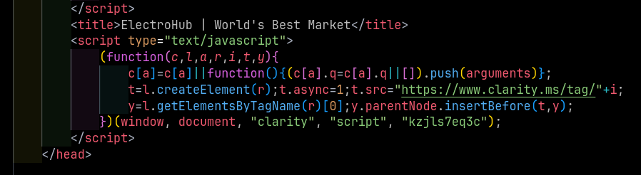

This code snippet demonstrates how to manually install Microsoft Clarity tracking code into a website. The tracking code is inserted into the **<head>** element of the HTML document. It asynchronously loads the Clarity script from Microsoft's servers using the provided tracking ID (**kzjls7eq3c**). This allows Clarity to start capturing user interactions on the website.

**Dashboard Overview:** The dashboard provides various metrics to gauge user interaction:

Sessions:

* Total Sessions: 12
* Excluding bot sessions: 0
* Average Pages per Session: 2.67
* Average Scroll Depth: 33.31%
* Active Time Spent: 25 seconds out of 1.5 minutes total time

Users Overview:

* Live Users: 1 user was active 1 minute ago
* Unique Users: 10
* Sessions with New Users: 100% (12 sessions)
* Sessions with Returning Users: 0% (0 sessions)

Insights:

* Rage Clicks: 8.33% (1 session)
* Dead Clicks: 50% (6 sessions)
* Excessive Scrolling: 0% (0 sessions)
* Quick Backs: 66.67% (8 sessions)

Top User:

* Country: India
* Sessions: 2

Based on these insights, we can draw the following conclusions:

User Engagement:

* The average number of pages per session is relatively high, indicating that users are exploring multiple pages within the application.
* However, the average scroll depth and active time spent are relatively low, suggesting that users may not be thoroughly ­­­engaging with the content or spending enou­­gh time on the site.

User Behaviour: Rage clicks and dead clicks are observed, indicating potential frustrations or usability issues within the application that may require attention.

* Quick backs are quite common, suggesting users are navigating away from pages quickly, possibly due to not finding what they are looking for.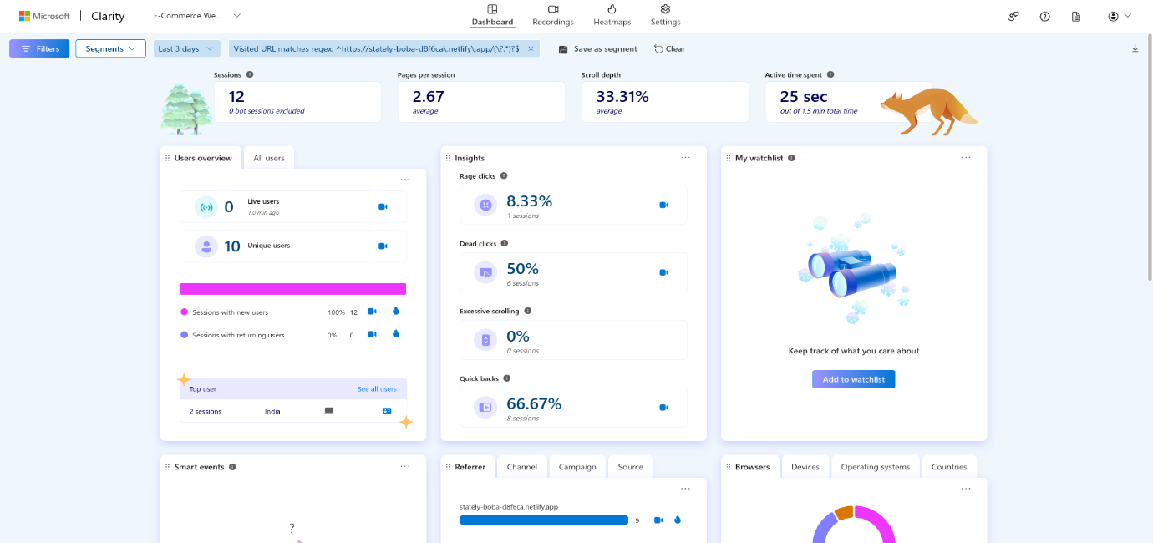

**Session Recordings:** Session recordings offer detailed insights into user interactions by capturing data such as date, time, location, clicks, and page views. These recordings are instrumental in identifying frequently used features within applications. Segmentation of recordings, close observation of user interactions, and analysis of click patterns aid in this process.

User Activity Overview:

* The data shows several user sessions on the website "stately-boba-d8f6ca.netlify.app" within the specified time frame.
* Sessions range from a few seconds to several minutes in duration.
* Majority of users are from India, using various operating systems such as MacOS, Windows, and Linux, predominantly on PCs.

User Behaviour Analysis:

* The number of clicks per session varies, with some sessions having relatively low clicks (e.g., 1) and others having significantly higher clicks (e.g., 72, 89).
* Most sessions involve multiple page views, indicating user engagement with the content.

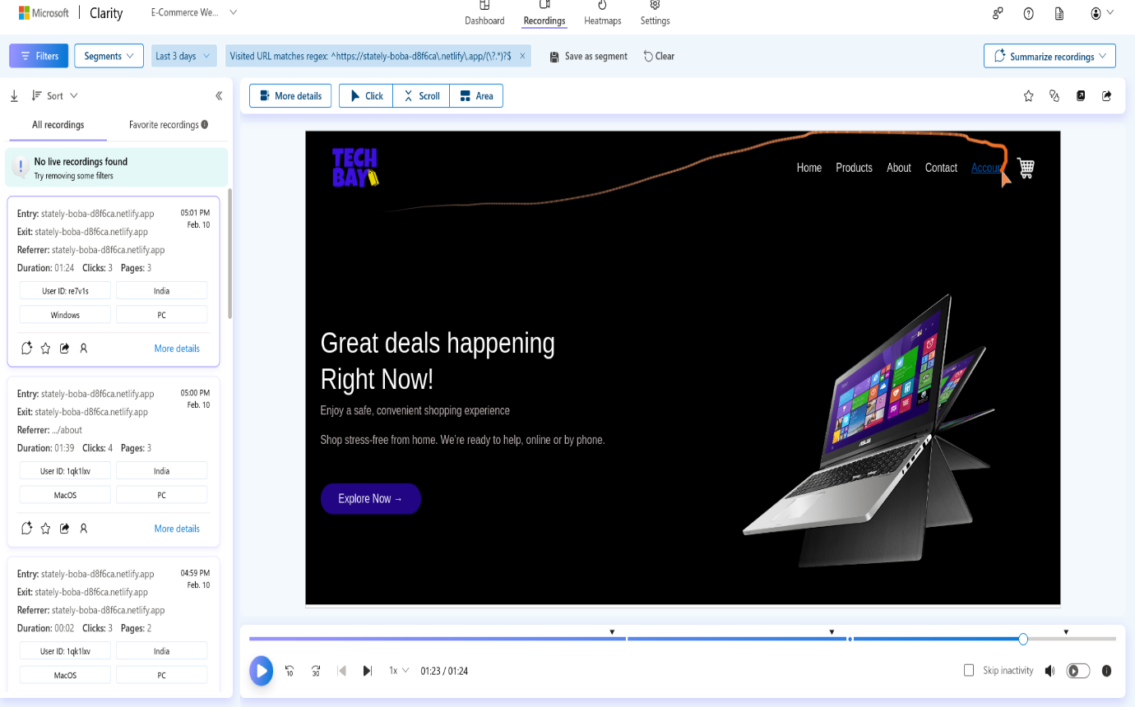

**Heatmap Analysis:** The heatmap feature is pivotal in identifying the most clicked-on features within an application. It provides insights into click distribution and engagement levels for various elements. Factors such as number of clicks, click-through rate (CTR), position on the page, contextual relevance, and conversion rates are considered in ranking elements. Filtering options allow for pinpointing clicks on specific types of elements like buttons, links, or images.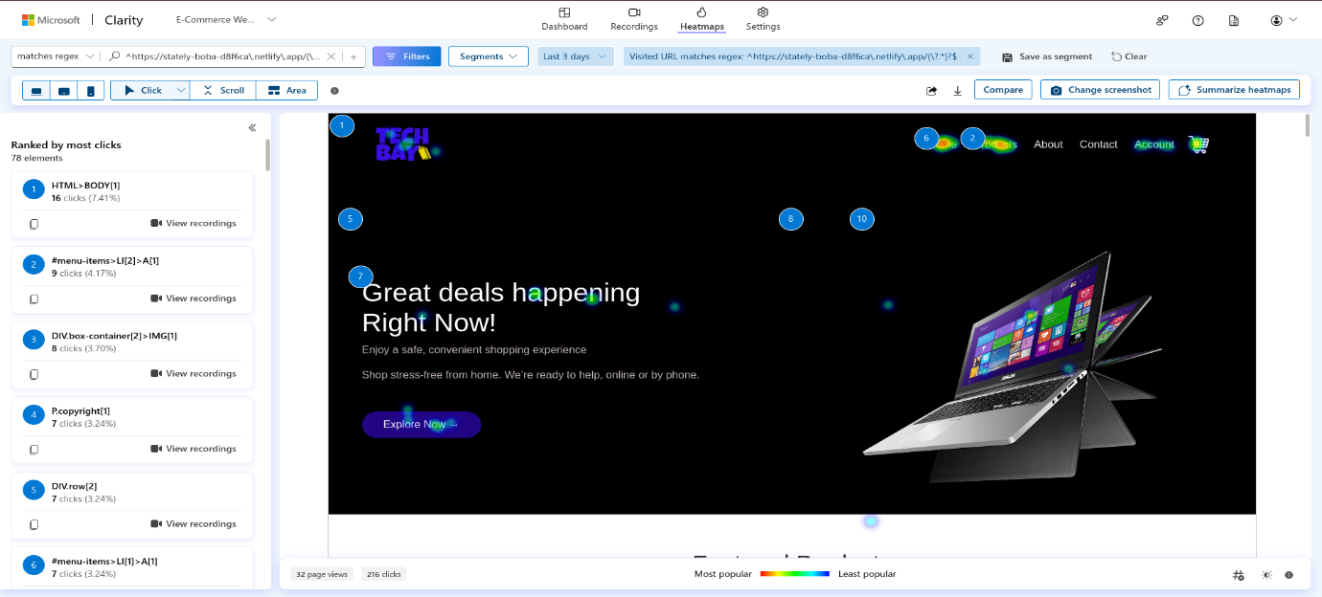

**Conclusion**

The analysis of user interactions on the website "stately-boba-d8f6ca.netlify.app" provides valuable insights into user behaviour and engagement patterns. Over the last 3 days, a total of 216 clicks were recorded across various elements on the website.

The top-clicked elements include the body of the HTML document, menu items, images within container elements, copyright text, and specific divs within rows. These interactions highlight areas of user interest and engagement with different components of the webpage.

Additionally, session recordings reveal user activity, with sessions ranging from a few seconds to several minutes in duration. Most users access the website from India, primarily using PCs running different operating systems.

By leveraging these insights, website owners and developers can make informed decisions to refine the website's design, content layout, and functionality, ultimately driving increased user engagement and achieving their business objectives. Regular monitoring and analysis of user interactions will be essential for ongoing optimization and continuous improvement of the website.